Shane Fleming

Project 2: Employee Attrition Analysis

Reducing Employee Attrition at Canterra

Executive Summary
Canterra Corporation experiences 16.1% annual employee turnover. Analysis of 4,410 employee records reveals that age and job satisfaction are the strongest predictors of attrition, offering clear opportunities for targeted retention strategies.
Key findings from the analysis:
- Employees under age 30 have 27.9% attrition compared to 11.2% for those over 40—more than double the risk
- Low job satisfaction (scores 1-2) correlates with 19.7% attrition versus 13.9% for high satisfaction (scores 3-4)
- A predictive model can identify 45% of employees who will leave, enabling proactive retention efforts
- Targeted programs for younger employees could retain approximately 105 additional employees annually

Introduction

The Business Challenge
Canterra employs approximately 4,000 people but loses roughly 600 employees annually (15% turnover rate per assignment context). Each departure creates costs through recruitment, onboarding, lost productivity, and knowledge transfer. Beyond direct costs, departures delay projects and strain client relationships.
Management believes job satisfaction and demographic factors influence attrition but lacks data-driven insights to guide retention investments. This analysis addresses that gap.

Analytical Approach
We analyzed employment data from 4,410 employees, examining relationships between attrition and factors including age, gender, job satisfaction, and income. Using logistic regression modeling, we identified which factors most strongly predict departure and developed a predictive tool to assess individual risk.

Key Findings

Finding 1: Age Strongly Predicts Attrition
Younger employees leave at substantially higher rates. Employees who left averaged 33.6 years old compared to 37.6 years for those who stayed—a 4.0 year difference.
Age Group | Attrition Rate
Under 30 | 27.9%
30-40 | 13.7%
Over 40 | 11.2%

The under-30 group represents 22% of the workforce but experiences attrition rates 2.5x higher than employees over 40. This age group presents the highest priority target for retention programs.

Finding 2: Job Satisfaction Critically Impacts Retention
Job satisfaction emerged as a strong predictor. Employees with low satisfaction (levels 1-2) experience 19.7% attrition compared to 13.9% for those with high satisfaction (levels 3-4)—a 5.8 percentage point difference.
The model quantifies this relationship: each one-point increase in job satisfaction reduces attrition odds by 23%. This suggests investments in workplace culture, management quality, and employee engagement could yield measurable retention improvements.

Finding 3: The Predictive Model Identifies At-Risk Employees
We developed a predictive model using age, gender, and job satisfaction. The model demonstrates good discriminatory ability and practical utility:
- Identifies 45% of employees who will leave (recall)
- Of employees flagged as at-risk, 27% will actually leave (precision)
- Applied company-wide, would flag approximately 1,050 employees for retention attention
The model's 27% precision means roughly one in four flagged employees will leave. While this may seem low, retention conversations benefit all employees, making false positives acceptable. The 45% recall means the model catches nearly half of actual departures, enabling meaningful intervention opportunities.

Finding 4: Age Effects Are Substantial
To illustrate the age relationship, consider two employees with average job satisfaction:
- A 30-year-old employee has 20.3% predicted attrition risk
- A 43-year-old employee has 10.6% predicted attrition risk
- Difference: 9.7 percentage points
This nearly two-fold difference in risk between early and mid-career employees underscores the importance of age targeted retention strategies.

Recommendations

Priority 1: Launch Targeted Retention Program for Younger Employees
With 22% of the workforce under age 30 experiencing 27.9% attrition, this group requires focused attention. Recommended initiatives:
- Structured mentorship pairing early career staff with experienced employees
- Clear 3-5 year career development pathways with defined advancement criteria
- Quarterly 'stay interviews' to proactively address concerns before resignation decisions
- Market-competitive compensation reviews for the 25-35 age demographic
Potential impact: If these programs reduce under 30 attrition to the company average (16.1%), Canterra would retain approximately 105 additional employees annually.

Priority 2: Implement Systematic Job Satisfaction Monitoring
Given that low satisfaction correlates with 42% higher attrition, systematic measurement and response mechanisms are essential:
- Deploy quarterly pulse surveys measuring satisfaction across key dimensions
- Require manager action plans when direct reports score below satisfaction level 2.5
- Include team satisfaction metrics in manager performance evaluations
- Invest in manager training focused on employee engagement and retention
Even modest improvements in satisfaction could meaningfully reduce attrition given the model's finding that each satisfaction point reduces odds by 23%.

Priority 3: Deploy the Predictive Early Warning System
Operationalize the predictive model to enable proactive retention:
- Score all employees quarterly using age, gender, and satisfaction data
- Flag employees with predicted risk above 20% for HR and manager attention
- Train managers on conducting effective retention conversations
- Track intervention outcomes and refine the model with updated data
Implementation would identify approximately 1,050 at-risk employees annually, enabling targeted retention efforts before departure decisions are made.

Priority 4: Address Gender Differences
Males show 12% higher attrition odds than females. While the difference is smaller than age or satisfaction effects, it suggests value in understanding and addressing gender-specific retention drivers through focus groups and tailored programs.

Implementation Timeline
Phase | Timing | Key Milestones
Phase 1:  Foundation | Months 1-3 | Launch satisfaction surveys  Score employees with model  Identify highest-risk groups
Phase 2:  Program Launch | Months 4-6 | Deploy young professional program  Implement stay interview process  Train managers on retention
Phase 3:  Refinement | Months 7-12 | Measure program effectiveness  Update model with new data  Expand successful initiatives

Conclusion
Canterra's 16.1% attrition rate is driven by identifiable, addressable factors. The data clearly demonstrates that younger employees and those with lower job satisfaction face substantially elevated departure risk. With focused programs targeting these populations and a predictive model to enable early intervention, Canterra can meaningfully improve retention.
The opportunity is substantial: retaining even 105 additional employees annually through the young professional program alone would significantly reduce turnover related costs while improving project continuity, client relationships, and organizational knowledge retention.
We recommend immediate initiation of Phase 1 activities, with full program deployment over the subsequent six months. The predictive model provides Canterra with a competitive advantage the ability to intervene proactively with at-risk employees rather than reacting to resignations.

Appendix: Technical Methodology

Data and Methodology
Analysis used 4,410 employee records with 711 departures (16.1% attrition). Variables: age, gender, job satisfaction (1-4 scale), income, employment history. Missing values (<2%) imputed using medians. 60/40 train-test split with stratification.
Why Logistic Regression? Appropriate for binary outcomes because it: (1) produces probabilities bounded 0-100%, (2) provides interpretable coefficients, (3) handles mixed data types, (4) captures non-linear relationships. Linear regression would predict impossible probabilities outside 0-100%.

Figure A1: Attrition Rate by Age Group
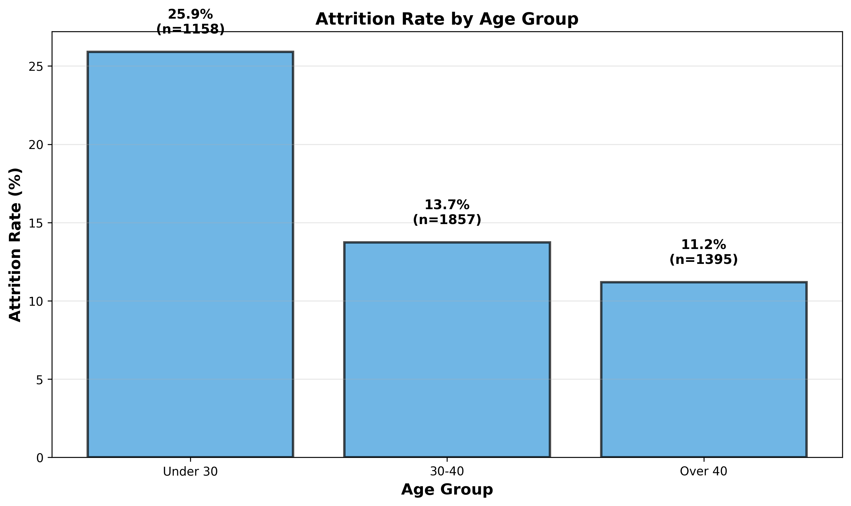
Under-30 employees have 25.9% attrition vs. 11.2% for over-40, a 2.3x difference demonstrating age as the strongest predictor.

Model Development and Selection
Four models tested: (1) Age only, (2) Age+Gender, (3) Age+Gender+JobSatisfaction, (4) Model 3+Income+Interaction. Model 3 selected for optimal balance: AUC=0.634, interpretable, economical. Model 4 added minimal additional value.

Figure A2: ROC Curves Comparing All Models
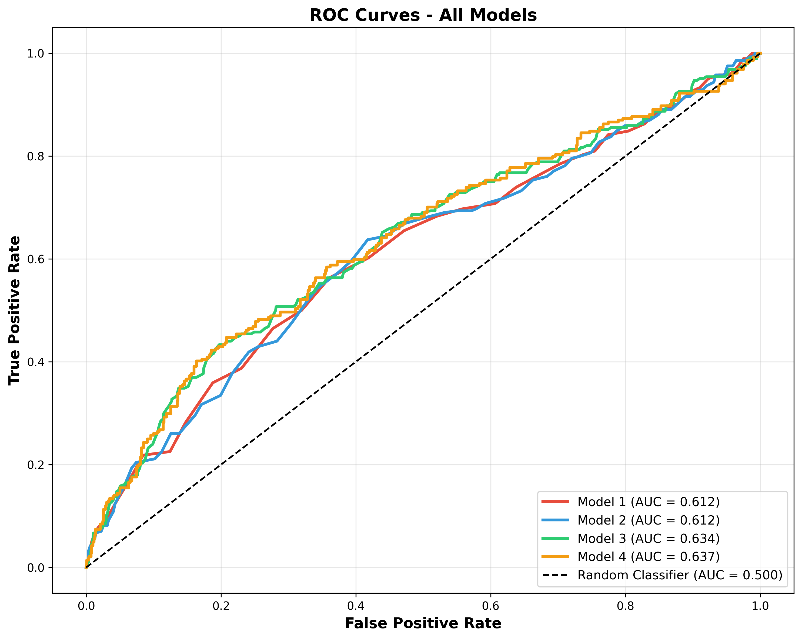
Models 3 and 4 show similar discriminatory ability (AUC ~0.634) and outperform simpler models. Diagonal line represents random guessing.

Performance Metrics and Model Coefficients
Performance Metric | Value
AUC (discriminatory ability) | 0.634
Recall at 20% threshold | 45%
Precision at 20% threshold | 27%
Variable (Model 3) | Effect on Attrition Odds
Age (per year) | -5.7% change
Gender (Male vs Female): 12.3% higher odds. Job Satisfaction (per point): -23.1% change in odds.
Note on threshold: Initial cutoff specified was .5/50%, but with 16% attrition, probabilities rarely exceed 50%. Analyzed multiple thresholds and 20% selected as practical cutoff.

Figure A3: Job Satisfaction Impact on Attrition
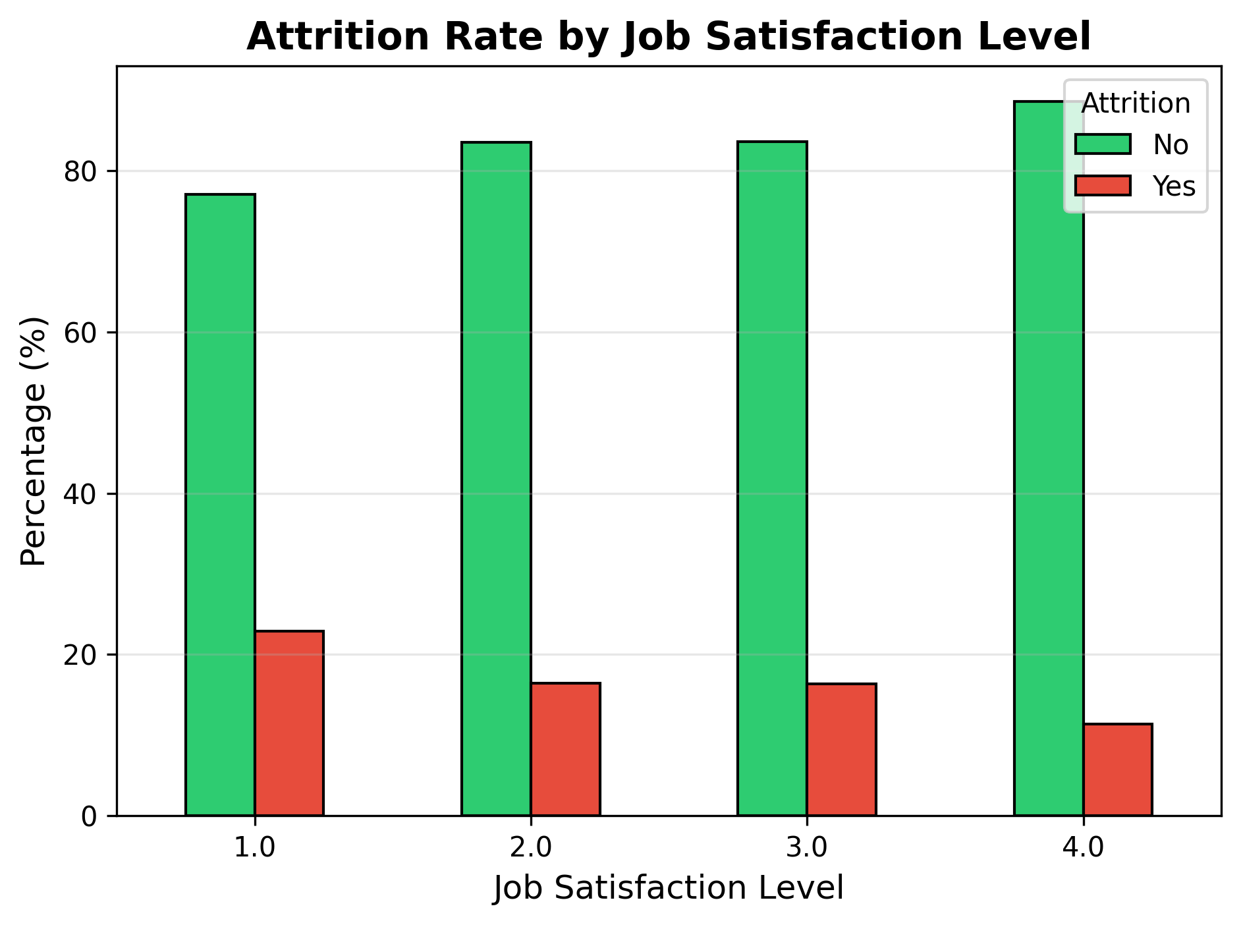
Satisfaction level 1: 22.9% attrition vs. level 4: 11.4%, demonstrating strong inverse relationship.

Figure A4: Predicted Attrition Probability by Age
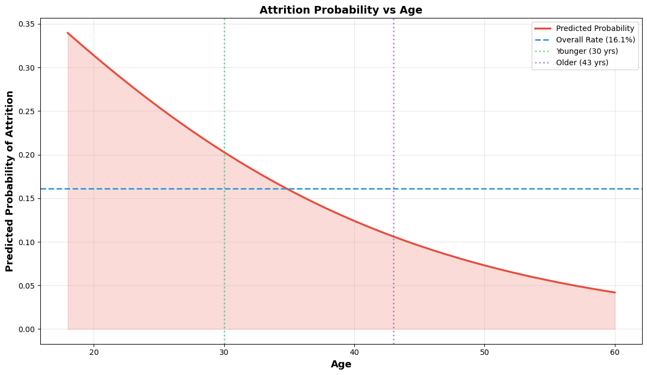
Sigmoid curve shows non-linear age to attrition relationship. Age 30: ~20% risk; Age 43: ~11% risk.

Probability Distributions and Limitations
Marginal distribution: 16.1% overall (no predictors). Conditional: Age 30 = 20.3% risk; Age 43 = 10.6% risk. Difference: 9.7 percentage points.
Limitations: This analysis cannot capture unmeasured factors (external opportunities, personal circumstances); predictions are probabilistic; model requires quarterly updates to maintain accuracy.
Note: Claude.ai was used to assist in formatting this report and the associated python notebook.

